**ASSIGNMENT 2**

**Basic Linux Commands**

# **Topic: Basic Linux Commands**

ASSIGNMENT 2 Date: 28/06/2022

**Screenshot of commands:**

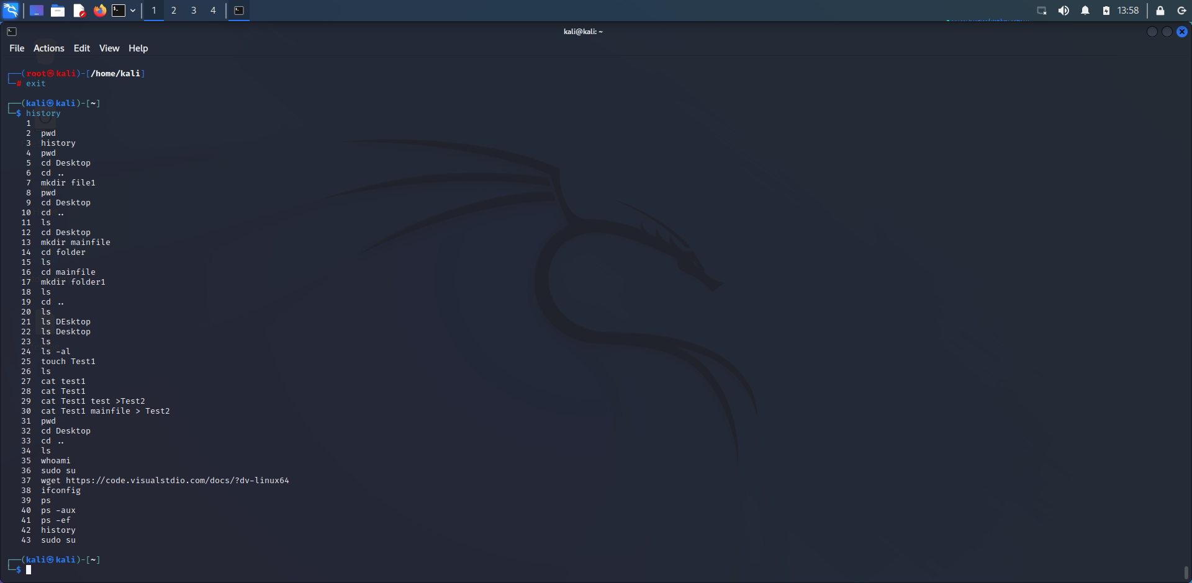

**Screenshot of commands in the Root:**

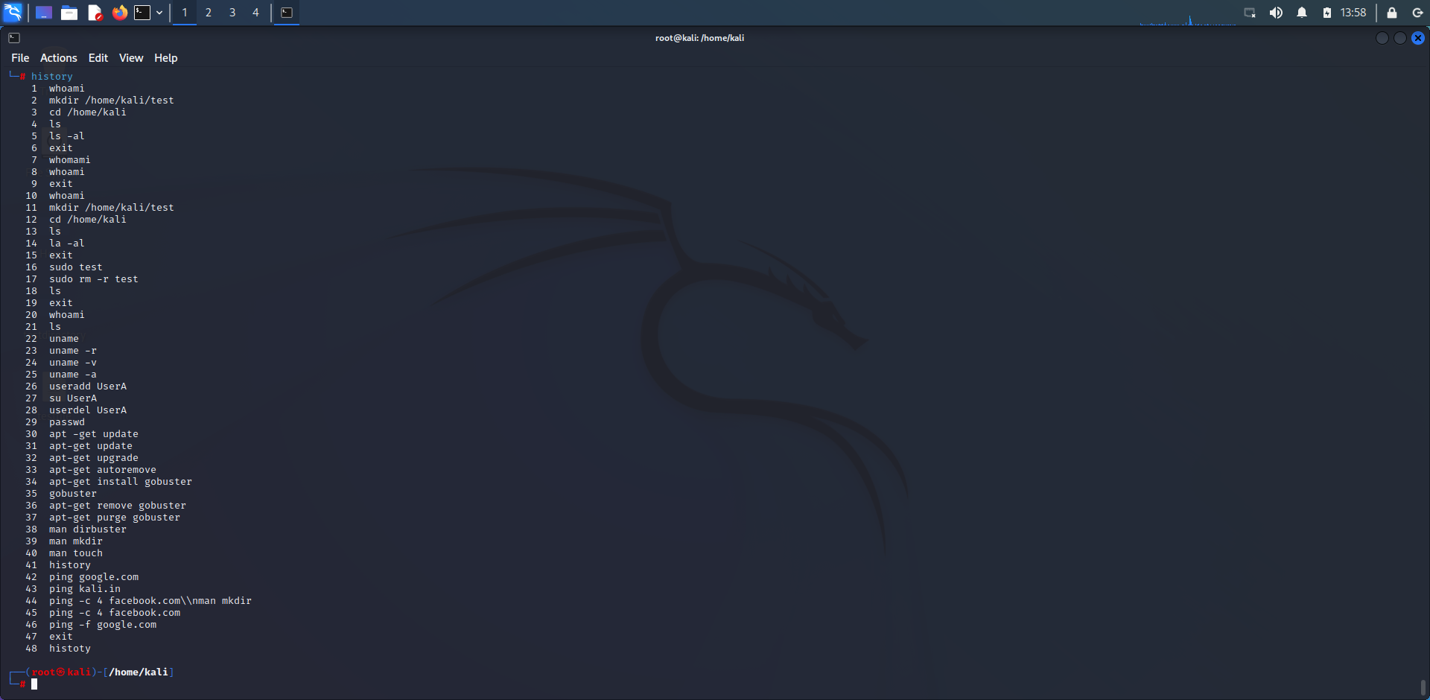

**Name: I PRASANTI**

**Sic: 20BCEA56**

**Branch: CEN**